\*Name: Jebediah Augustine

+Age: 34

+Height: 6'0"

\*Party Affiliation: Patrian party for Equality

\*Personality: Pretty serious when necessary, in the middle point between being close minded and open minded, kinda normal tbh

+Likes: Owning things, jokes, coffee

+Dislikes: Eggs, annoying people, heat

\*Description(Or Image): 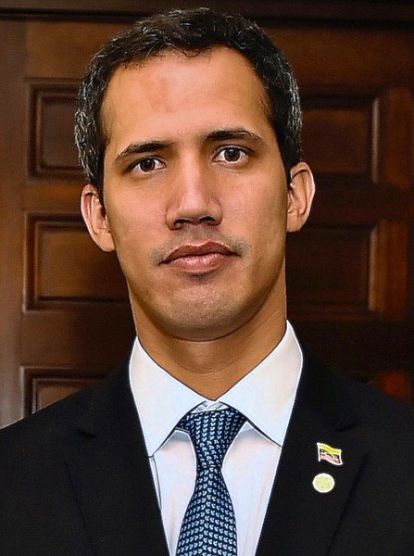

\*Bio: Born in a middle class family with Spanish descent in the west of Patrium, Jebediah had a rather normal childhood, up until his father left to work for the army when he was 12, only 3 months later he found out that his father had died in a shootout against a guerrilla group in the countryside, this affected him and made him fall into deppresion for a few months, before getting back on track, with his mother and his dad's family helping. In school he generally had good grades, and when it came to deciding a profession to study, he chose political science, being very interested in the topic, and exceeding in the class. After he finished with his studies, he was left in some economic struggles due to debt, so he initially had to work in minor jobs. After a couple of years of working hard, though, he managed to get into Patrian politics, first starting with a small independent party, and eventually forming his own with other senators, the PPE.